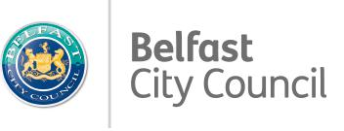**PEOPLE AND COMMUNITIES COMMITTEE**

|  |
| --- |
| **There are no significant ethical or legal concerns with the contents of the following report. Data protection and discrimination are not a concern.** |

|  |  |
| --- | --- |
| **Subject:** | The trends in anti-social behaviour in the Lisburn Road crime neighbourhood |
| **Reporting Officer:** | James Bailey |

|  |
| --- |
| **Is this report restricted? YES [ ] NO [X]** |

|  |  |
| --- | --- |
| **1.0** | **Purpose of Report or Summary of Main Issues** |
| 1.1  1.2 | The purpose of this report is to provide observations and recommendations to members on:  *‘members’ – councillors of this committee who are ‘responsible for the development and implementation of strategies, policies, programmes and projects aimed at improving life at a local level’*  - The anti-social behaviour context in the Lisburn Road crime neighbourhood and the wider Northern Ireland context  - The frequency of anti-social behaviour in the Lisburn Road crime neighbourhood  - The anti-social behaviour hotspots in the Lisburn Road crime neighbourhood  - The perception of anti-social behaviour from local people in Belfast City *politician’s main judge of their performance is their voters. They should be reactive to what issues they are concerned about.*  - The crimes influencing a rise in anti-social behaviour  - The anti-social behaviour and crime situation in parks and open spaces |
| **2.0** | **Sources for report** |
| 2.1  2.2  2.3 | *The committee members need to be informed of what sources I am using to analyse anti-social behaviour to present a more convincing case for my recommendations.*  This report will use street crime data sourced from the PSNI from the period January 2016-January 2017. As such, the data used for the analysis will only relate to anti-social behaviour incidents reported to the police, and not incidents reported to other agencies, for example Belfast City Council.  The report will use information drawn from the Northern Ireland Crime Survey to complement the policing data to provide a more complete measure of the prevalence of types of anti-social behaviour crime in local areas.  This report cannot claim to encompass the full extent of anti-social behaviour in the Lisburn Road crime neighbourhood. *Acknowledging the limitations of the data used for decision making.* |
| **3.0**  3.1  3.2 | **Recommendations**  *This is the main purpose of the report. Committee members can endorse work proposed in the report to reduce anti-social behaviour offences.*  Members are asked to consider the contents of the report.  Members are also asked to note the progress to date and endorse the future work planned to address these issues more effectively. *These statements are taken verbatim from the anti-social behaviour report I based the template of this report on.* |
| **4.0**  4.1  4.2  4.3  4.4  4.5  4.6  4.7 | **The anti-social behaviour context in Lisburn Road crime Neighbourhood and the wider Northern Ireland context**  The official anti-social behaviour definition from the PSNI: ‘Anti-social behaviour covers a wide range of unacceptable activity that causes harm to an individual, to their community or to their environment. This could be an action by someone else that leaves you feeling alarmed, harassed or distressed. It also includes fear of crime or concern for public safety, public disorder or public nuisance.’ *This is to make clear what data my analysis is based on has defined as anti-social behaviour.*  Anti-social behaviour in Northern Ireland rose by 5% from 2016 to 2017.  Anti-social behaviour in Northern Ireland was most frequent in the month of October in both years.  Anti-social behaviour was most prevalent in the spring and summer. This could be contributed to more outdoor activity, with parties encouraging on street drinking.  There is a strong relationship between high average temperature months and high anti-social behaviour months, with the highest October has high anti-social behaviour occurrences while not being a typically hot month. This could be attributed to Halloween celebrations.  Belfast City’s four crime neighbourhoods (Lisburn Road, Tennent Street, Woodbourne, Strand Road) rank top of the 26 policing neighbourhoods in Northern Ireland by anti-social behaviour occurrences per population. *Audience is Belfast Councillors and therefore I use Belfast as the problem area.*  Lisburn Road neighbourhood is the highest ranking anti-social behaviour neighbourhood in Northern Ireland with anti-social behaviour crimes in the two years being more than half of the population of the neighbourhood. *I have provided the statistic in this way to present the problem as being large by comparing directly with the population. This will emphasise Lisburn Road as being a problem neighbourhood.* |
| **5.0**  5.1  5.2  5.3  5.4 | **The frequency of anti-social behaviour in the Lisburn Road crime neighbourhood**  **SEE FIGURE 1**  The highest occurrence of anti-social behaviour crimes (9.88%) occurred in 2016-2017 in the month of September.  In other crime neighbourhoods, the highest occurrence of anti-social behaviour crimes occurred in October (9.71%). This supports the police finding that they find an increase in reports at the key time of Halloween.  In March, there is a 1.33% increase in distribution of crimes occurring in the Lisburn Road area than in other crime neighbourhoods.  **I recommend the committee to approve prioritising resources on March and September as months of concern for anti-social behaviour and encouraging the exercising of the wide**  **range of criminal and civil powers available to the council to reduce anti-social behaviour crimes in these months.** |
| **6.0**  6.1  6.2  6.3  6.4  6.5  6.6  6.7  6.8 | **The anti-social behaviour hotspots in the Lisburn Road crime neighbourhood**  Members will be aware that there are areas in the Lisburn Road crime neighbourhood which do have a high level of anti-social behaviour. *Recognising the member’s extensive knowledge of their local area.*  The Holylands area has been identified as an anti-social behaviour hotspot which contributes to higher anti-social behaviour occurrence in the months March and September in the Lisburn Road crime neighbourhood.  16% of anti-social crime in 2016-17 happened within the Holylands area.  **SEE FIGURE 2**  In 2016 and 2017, August is low for anti-social behaviour crimes in the Holylands, which is not consistent with the general summer rise in anti-social behaviour in Northern Ireland. This disparity could be attributed to the transient accommodation habits of those living in the area.  There was a notable 60% rise in 2017 from 2016 in the month of March.  **Members will be aware that there has been extensive press coverage of this area during key times and it should be our priority to tackle the anti-social behaviour problems of this area, which will improve the stigma of the area any negative publicity generates.**  **Members will be aware that Belfast City Council have provided a response to residents with safer neighbourhood, alcohol enforcement and noise teams working with the PSNI at key times of the year like St Patrick’s Day and Freshers Week. We need to investigate why the response was not as effective in March 2017.** *Acknowledgements of efforts made by the committee previously in the area.*  **The council should launch an educational advertising campaign in March and September targeted in the area warning people of the consequences of criminal actions to their career. The influence of alcohol can make young people perform petty crime and criminal damage they would not otherwise participate in.** *direct recommendation to solve the problem in the Holylands.* |
| **7.0**  7.1  7.2  7.3  7.4 | **The perception of anti-social behaviour from local people in Belfast City**  **SEE FIGURE 3**  People using or dealing drugs is the top perceived biggest anti-social behaviour problem in Belfast City, closely followed by rubbish or litter lying around.  Compared to other districts, people using or dealing drugs is perceived approximately 10% more by people living in Belfast City than any other district.  Abandoned or burnt out cars is viewed as the least significant problem  **The council should work with the PSNI in investigating methods to curtail drug misuse. The council can exercise closures to deal with premises where drug misuse is causing nuisance or disorder.** *Recognising the council’s powers to deal with drug misuse* |
| **8.0**  8.1  8.2  8.3  8.4  8.5 | **The crimes influencing a rise in anti-social behaviour**  **SEE FIGURE 4**  Members will be aware drug crime is considered to play a role in perpetuating other types of anti-social behaviour.  I did not find drugs to be a major influence of anti-social behaviour in peak months in the Holylands. Drug crime in the high anti-social behaviour month of March does not see a rise in drug crime compared to the lowest occurring month of August.  Criminal damage and arson is approximately 10% higher in the Holylands in March than in August.  **The council should collaborate with the police categorising recorded anti-social behaviour statistics into categories that include the influence of drugs and of a criminal damage and arson nature, for example vandalism. This will allow for a more thorough analysis into the causes of anti-social behaviour.** *Encourage the council to act more on data they have.*  **Members will be aware that emerging issues that may contribute to ASB and if they are identified like criminal damage and arson in the Holylands area we can prevent further escalation. It is a crime that may contribute to an area being an anti-social social behaviour hotspot. People’s physical settings and surroundings are known to impact positively or negatively on mood and sense of well-being, and therefore it is important we address this.** *Human factor - the impact of the rise in criminal damage and arson.* |
| **9.0**  9.1  9.2  9.3  9.4  9.5  9.6 | **The anti-social behaviour and crime situation in parks and open spaces**  There are several parks and open spaces that are subject to persistent anti-social behaviour. The top three parks and open spaces (excluding parks deemed by visual analysis to have too much interference from other localities) with crimes within 0.3km were:   * Bridges Urban Skate Park – 1156 crimes * Botanic Gardens – 465 crimes * Gasworks – 442 crimes   Illicit drug users may occupy public spaces or amenities in order to use drugs and often there is physical evidence of anti-social behaviour in parks.  **SEE FIGURE 5**  There are approximately 1% more drug crimes occurring in parks/open spaces near the Lisburn Road. This suggests a relationship with open spaces.  There are approximately 0.5% more anti-social behaviour crimes in a 0.3km radius in the Lisburn Road neighbourhood than in the rest of Northern Ireland.  **Members will be aware that there are 24 park wardens focusing on addressing community safety within parks. With these findings, they should be conscious of crimes more prevalent in park and open areas and report any emergent issues. The council should hire additional park wardens working after the parks close to observe a night time economy that may be underreported in the data used.**  **Public spaces change over time as a result of physical effects caused. The environment can also change as a result of the people using or misusing that space. The greater prevalence in drug crimes could result in discarded drugs paraphernalia which is littering, a type of anti-social behaviour.** |
| **10.0** | **Appendices – Graphs Attached** |

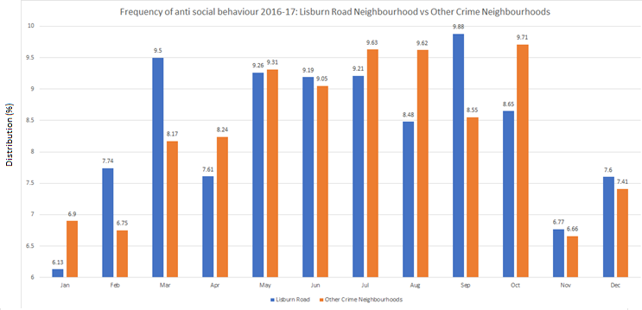

Figure 1 Graph showing the distribution of occurrences in crime each month 2016-2017. *orange and blue colours to show contrast.*

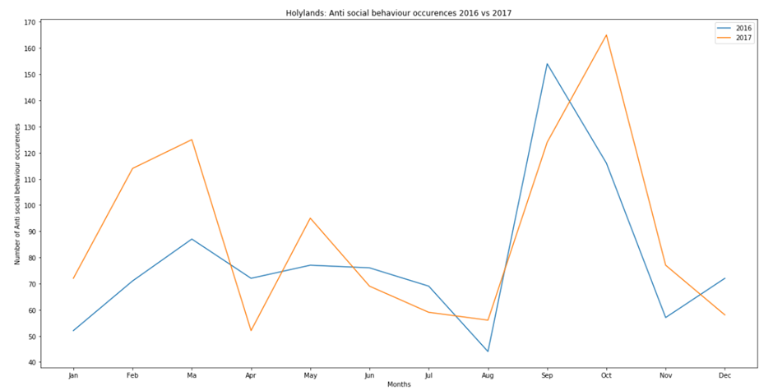

Figure 2 Graph showing the occurrences of anti-social behaviour in the Holylands area each month 2016-2017. *orange and blue colours to show contrast.*

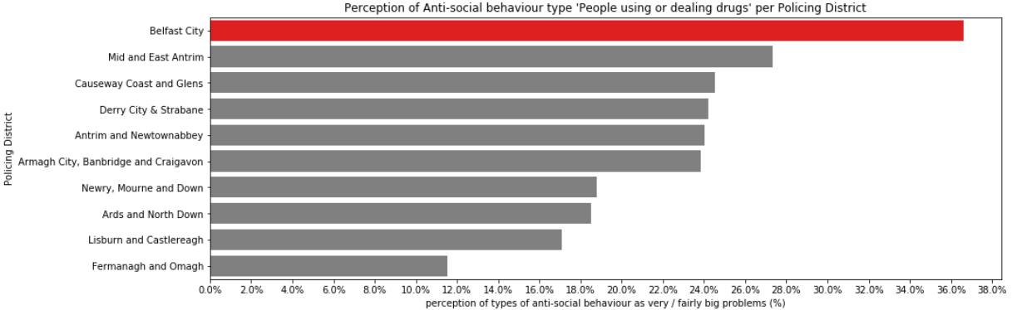

Figure 3 Comparing perception of ‘People using or dealing drugs’ in Belfast City with other policing districts *red for association with ‘warning’, ordered highest first*

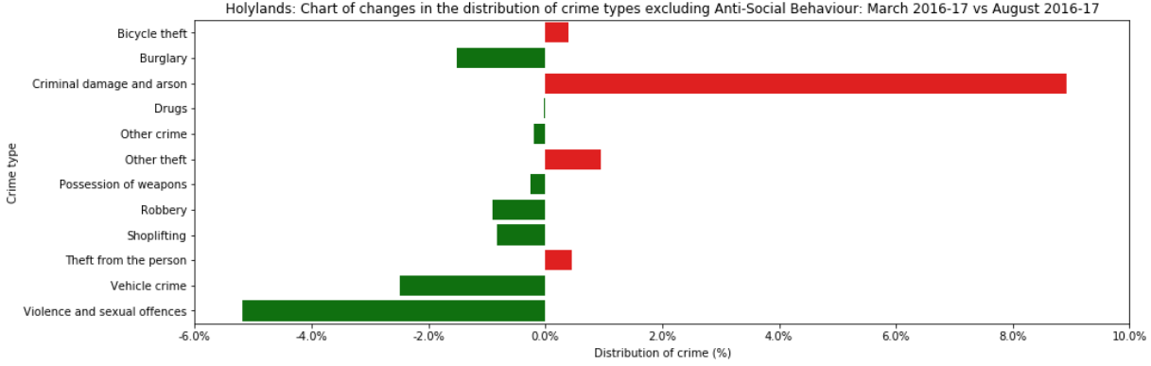

Figure 4 comparing each crime type’s distribution in the months March 2016-2017 and August 2016-2017 *green to show a decrease in that area (positive observation), red to show an increase in that area (negative)*

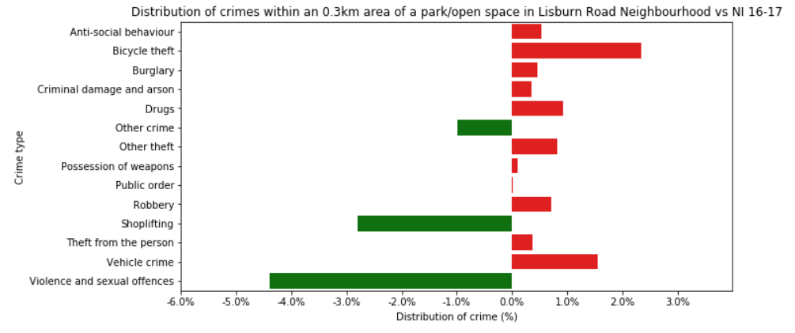

Figure 5 comparing each crime type’s distribution of crimes that are 0.3km from a park/open space in the Lisburn Road crime neighbourhood and the whole of the 2016-2017 crime data excluding crimes 0.3km from a park/space in Lisburn Road *green to show a decrease in that area (positive observation), red to show an increase in that area (negative observation)*